1. 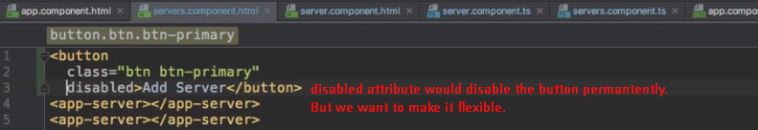
2. To make this disabled functionality dynamic, we can bind to it by enclosing it in square brackets. Square brackets indicate to angular that we’re using property binding that we want to dynamically bind some property